Capstone Project - Insta Approval

1. Introduction

Design an Approval System for a bank wherein any customer can get an approval for Interest Free Car Loans or Car Loans at 0% for first year basis their credit worthiness with proper documentation and registrations. This process needs to be automated, which should help bank customers in understanding the formalities clearly and get the Car Loans

2. Scope
The Approval System will enable customers to apply for Interest-Free Car Loans or Car Loans at 0% interest for the first year based on their creditworthiness. The system will allow customers to register, submit required documents, apply for the loan, and track their application status. It will automate the loan approval process, including verification of documents, credit score checks, and approval/rejection by the bank. The solution aims to simplify the process, improve transparency, and reduce manual effort for both customers and the bank.

3. Functional Requirements
- Customers should be able to register in the system with basic information.
- Customers should be able to apply for the loan by uploading the documents,filling required information .CIBIL Score will be provided by the bank.
- The requests can be updated or can be removed by Customer before any approval.
- Customer can track the status of the requests
- Loan upto 5L can be approved or rejected by Bank Admin, while giving remarks for the customer to understand the reason for rejection if any.
- Bank Admin can view all the pending loan request

4. Non-Functional Requirements
- Application should be responsive to display consistently across multiple device screens.

- Application needs to have separate front-end and back-end.

- Application needs to interact with a database for relevant data processing.
- Application should have been tested with success/failure instanc

UML Diagrams
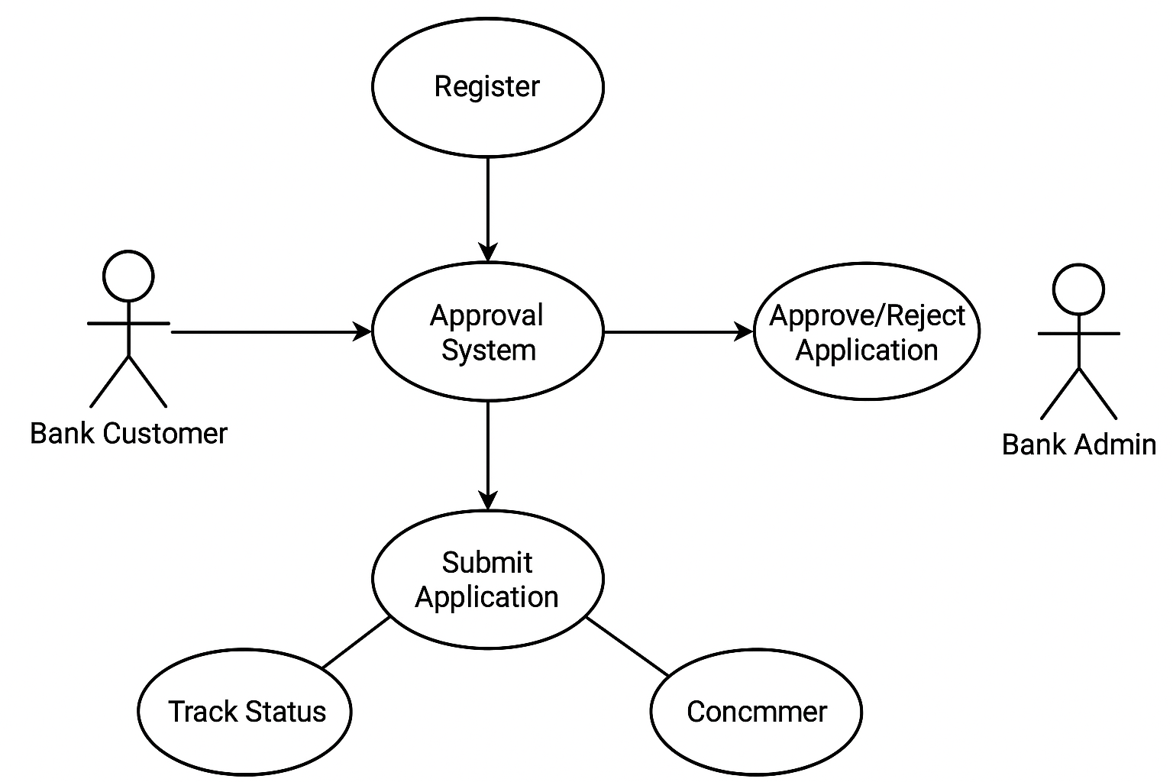

Key Screens (UI Components)

1. Landing Page / Home Screen
Purpose: Overview of the loan product and system features.
Key Elements:
"Apply for Loan" call-to-action button.
Information about loan benefits (Interest-free, 0% for first year).
Login/Register options.

2. Registration Screen
Purpose: New customers create an account.
Key Elements:
Input fields (Name, Email, Mobile, Password, Confirm Password, Address).
Validation (email format, strong password).
"Register" button with success/error feedback.

3. Login Screen
Purpose: Existing customers login securely.
Key Elements:
Username/Email & Password fields.
"Forgot Password?" link.
Redirect to Dashboard upon successful login.

4. Dashboard
Purpose: Central hub for customers after login.
Key Elements:
Status summary of loan applications (Pending, Approved, Rejected).
Option to Apply for New Loan.
Profile management (edit personal info).

5. Loan Application Form Screen
Purpose: Submit loan request with documentation.
Key Elements:
Form sections:
Personal Info (Auto-filled from profile).
Employment & Income Details.
Upload Documents (ID proof, income proof, etc.).
System fetches CIBIL Score automatically from bank API.
"Submit Application" button.

6. Loan Request Tracking Screen
Purpose: Customer tracks loan status.
Key Elements:
List of applications with:
Application ID
Status (Pending, Approved, Rejected)
Admin Remarks (if rejected).
Option to "Update" or "Withdraw" request (if still pending).

7. Admin Dashboard (Bank Admin)
Purpose: Bank Admin reviews and approves/rejects loans.
Key Elements:
List of pending applications.
View customer details & documents.
Buttons: Approve / Reject (with remarks field).
Filter by status, amount, CIBIL score.

8. Notifications / Alerts
Purpose: Notify customers of updates.
Key Elements:
Email/SMS in real-time for application status changes.
In-app notifications.

Frontend Flow (User Journey)
1. Customer Flow
Landing Page → Register/Login → Dashboard → Apply for Loan
→ Upload Documents → Submit Application
→ View/Track Status → Update/Withdraw (if Pending)
→ Receive Approval/Rejection Notification.
2. Admin Flow
Login (Admin) → Admin Dashboard → View Applications
→ Approve/Reject with Remarks → Customer Notified.
3. System Flow (Behind the Scenes)
Customer Submits Application → System Fetches CIBIL Score via API
→ Admin Reviews → Decision Updated in DB → Notification Sent to Customer.

Tech Suggestions for Frontend Flow
UI Framework: Angular (Material UI for forms & dashboards).
State Management: NgRx (for application status & notifications).
Routing: Angular Router (for multi-page flow).
File Upload: Angular File Upload + backend API.
Real-time Updates: WebSockets or polling for status changes.

Extended API Guidelines – Insta-Approval System

1. API Design Principles
Follow RESTful design principles.
Use HTTPS for all API endpoints.
Use versioning in URLs (e.g., /api/v1/...).
Return JSON for all responses.
Follow consistent naming conventions (e.g., /customers, /loans, /documents).

2. Authentication & Authorization
Use OAuth 2.0 / JWT tokens for authentication.
Ensure role-based access control (RBAC):
Customer Role: Can register, apply for loans, upload documents, and track status.
Admin Role: Can review, approve/reject loans, and provide remarks.

3. Endpoints (Sample)
Customer APIs:
POST /api/v1/customers/register – Register a new customer.
POST /api/v1/loans/apply – Apply for a car loan (with document upload).
GET /api/v1/loans/status/{loanId} – Check loan status.
PUT /api/v1/loans/update/{loanId} – Update loan details (before approval).
DELETE /api/v1/loans/cancel/{loanId} – Cancel loan request.
Admin APIs:
GET /api/v1/admin/loans/pending – Fetch all pending loan applications.
PUT /api/v1/admin/loans/approve/{loanId} – Approve a loan.
PUT /api/v1/admin/loans/reject/{loanId} – Reject a loan with remarks.

Entities and Relationships

Entities and Relationships
Entity | Attributes (Key Fields) | Relationships
Customer | CustomerID (PK), Name, Email, Phone, Address, DateOfBirth, CIBILScore, RegistrationDate | 1..* LoanApplication (One Customer can have multiple Loan Applications)
LoanApplication | ApplicationID (PK), CustomerID (FK), LoanAmount, ApplicationDate, Status (Pending/Approved/Rejected), Remarks | ..1 Customer, 1..1 LoanType, 1.. Document, *..1 Admin (for approval)
LoanType | LoanTypeID (PK), TypeName (Interest-Free Car Loan, Car Loan 0% First Year), Description | 1..* LoanApplication (One LoanType can have many Applications)
Document | DocumentID (PK), ApplicationID (FK), DocumentType (IDProof, AddressProof, IncomeProof), FilePath, UploadDate | *..1 LoanApplication (Each application can have multiple documents)
Admin | AdminID (PK), Name, Email, Role (LoanOfficer/Manager) | 1..* LoanApplication (Approves/Rejects Loan Applications)
ApprovalHistory | ApprovalID (PK), ApplicationID (FK), AdminID (FK), Action (Approved/Rejected), ActionDate, Remarks | *..1 LoanApplication, *..1 Admin (Track approvals/rejections over time)

Key Relationships (ERD-style in text):
Customer (1) → LoanApplication (M)
LoanType (1) → LoanApplication (M)
LoanApplication (1) → Document (M)
Admin (1) → LoanApplication (M) (for approval/rejection)
LoanApplication (1) → ApprovalHistory (M)
UX guidelines table with principles and implementation for the Insta-Approval System:
UX Principle | Guideline | Implementation in Approval System
Clarity | Use clear, jargon-free language throughout. | Use labels like "Upload Income Proof" instead of "Upload Document 1". Show loan eligibility messages in plain language.
Consistency | Maintain a uniform look and behavior across screens. | Use the same design pattern for buttons (Apply, Submit, Cancel) across all forms and steps.
Feedback | Provide immediate feedback for user actions. | Show progress indicators during document upload, success/error messages after submission.
Accessibility | Ensure usability for all users, including differently-abled. | Add keyboard navigation, proper color contrast, ARIA labels for form inputs.
Simplicity | Reduce cognitive load with minimal required inputs. | Auto-fetch CIBIL score from bank database instead of asking users to upload it.
Guidance & Help | Offer contextual help for complex steps. | Add tooltips or “?” icons explaining terms like CIBIL score or Interest-Free Period.
Trust & Security | Build confidence through transparency and safety. | Show a lock icon and “Your data is secure” note on the upload page; display bank’s privacy policy.
Mobile-First Design | Ensure seamless experience across devices. | Responsive layout for applying and tracking loan status on mobile devices.
Error Prevention | Prevent mistakes before they happen. | Validate fields (e.g., PAN format) before submission, disable Submit button until all mandatory fields are filled.

General Guidelines
Project Structure
◦ Maintain a consistent folder structure for frontend, backend, and documentation.
◦ Separate configuration files, source code, and assets for clarity.
Coding Standards
◦Use meaningful variable, function, and class names.
◦Maintain consistent indentation, spacing, and commenting.
Version Control with Git
◦Repository Setup: Initialize a Git repository at the project root (git init).
Branching Strategy:
▪ Use main (or master) for production-ready code.
▪ Create feature branches (feature/<feature-name>) for new features.
Documentation
◦Keep API specs, UI/UX guidelines, and system diagrams updated.
◦Include README with project setup, dependencies, and instructions.
Testing & Validation
◦Test features before committing.
◦Document test cases and outcomes for major modules.

